What is Checkstyle?

Checkstyle “… a development tool to help programmers write Java code that adheres to a coding standard.”

is a free source code analysis tool helps to improve your code quality by checking with certain pre-configured standards.

Help programmer to write code that adheres to standard practice

Check verify the source code and shows errors that violate coding standard for the project

Checkstyle is also available as a command line tool. If you have a different IDE other than Eclipse, plug-ins available for Netbeans, IntelliJ IDEA & etc.
If you interested on PMD Eclipse Plugin (another source code analysis tool), You can follow PMD Eclipse Tutorial
If you interested on Findbugs Eclipse Plugin (another source code analysis tool), You can follow Findbugs Eclipse Tutorial
If you interested on Sonar Eclipse Plugin (another source code analysis tool), You can follow Eclipse Sonar Tutorial

Checkstyle Tutorial
- Eclipse 3.7
- Checkstyle 5.6
You can install the Checkstyle Eclipse plugin using Eclipse update manager from the following links
- http://eclipse-cs.sourceforge.net/update

Checkstyle Installation
For Installing Checkstyle Plugin from eclipse, select Help->Install New Software Then click add, then provide Name and Location according to the following screenshot
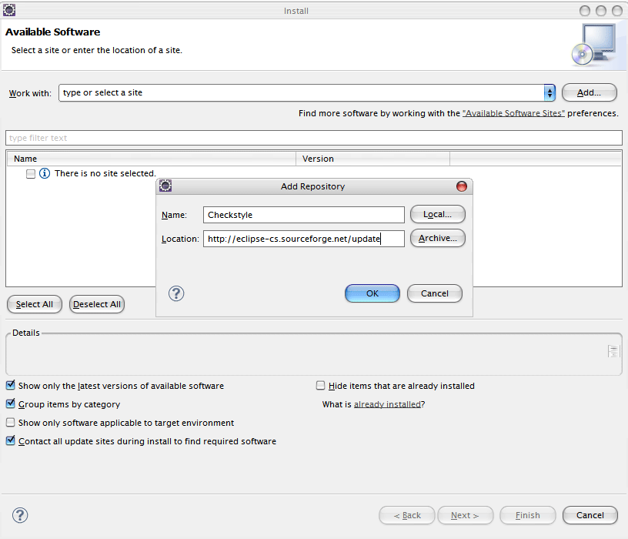
Then select the Checkstyle version click next and accept the license details, it will install the Checkstyle

Checkstyle Configuration
After install, you can configure Checkstyle from eclipse, Window->Preferences->Java->Checkstyle
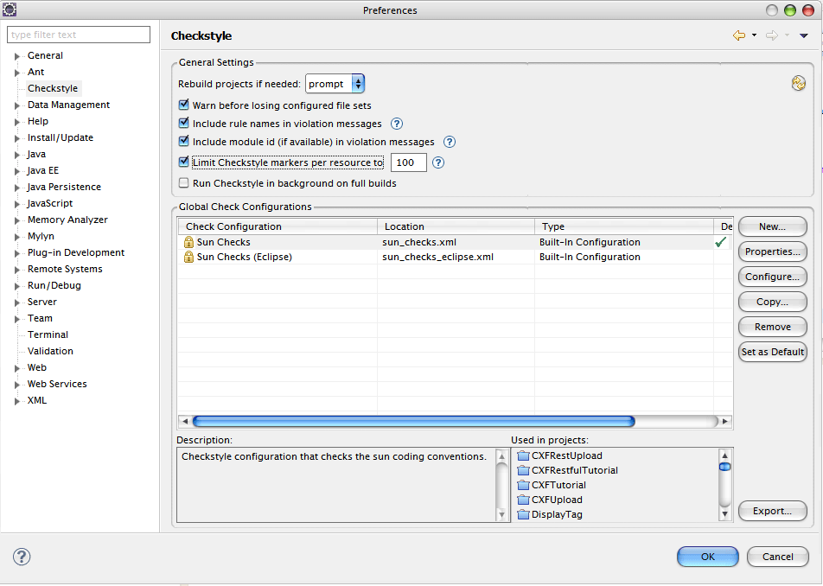

Using Checkstyle Plugin
You need to create a java project and add some class into src
Now, Build the project using Project->Build Project. Right click on the project, and run the Checkstyle according to following screenshot.
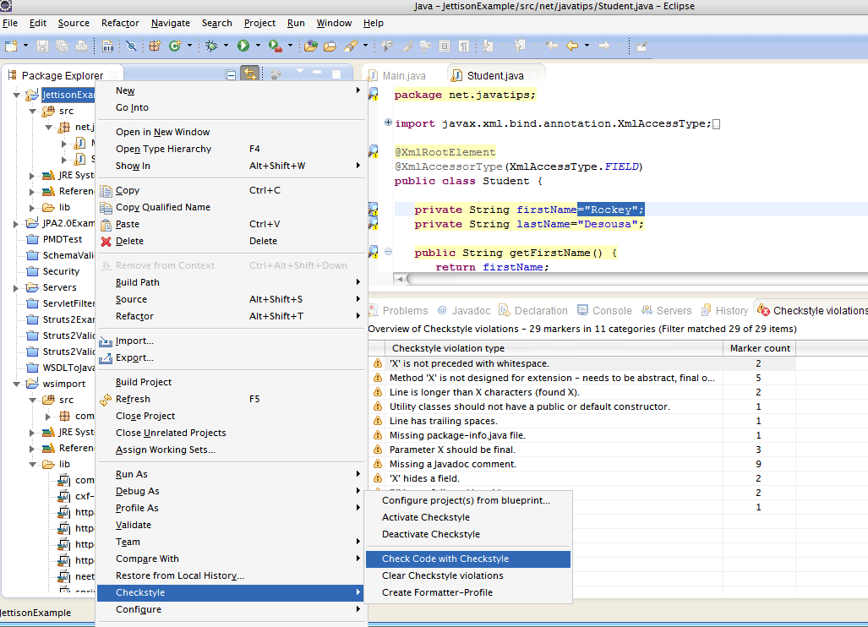
Now you can see a bug mark on the source code, Checkstyle violations will be shown ( You can also navigate to Window->Show View->Other->Checkstyle->Checkstyle violations).
From Checkstyle violations tab, You can get more detailed description about this bug(See the below screenshot).
